# LABORATORY “11”

# 3-D Printing Using Fused Deposition Modeling Technology and PLA Polymer

## Mohammed Alzayer Christopher Clay Xinhang Shen

## 

## Mat E 453 Lab Section 2 December 2, 2014

ABSTRACT

A 3-D printer that adopts fused deposition modeling (FDM) technology was used to produce a cubic part. The printer uses polylactic acid (PLA) filament as feedstock for printing and is also equipped with color additives. The printing process was repeated five times each at a different temperature. The temperatures were 190°C, 210°C, 230°C, 250°C, and 270°C. After producing five cubes at five different temperatures, the parts were studied under a stereomicroscope and photographs of their interfaces were taken to qualitatively compare the effect of temperature on viscosity and quality of the part.

1. INTRODUCTION

1.1 Extrusion

Extrusion is a fundamental method that is used in both additive manufacturing (3-D printing) and subtractive manufacturing (injection molding). In extrusion, a thermoplastic material with low viscosity is subjected to high temperatures and high shear rates in order to make it even less viscous. By doing so, the material will have the ability to flow more freely and more easily into a mold (injection molding) or a stage (3-D printing).

Thermosets are usually not a good choice for either manufacturing processes for several reasons. A thermoset material consists of cross-linked networks that are covalently bonded and hence cannot reform by heating. In general, it is difficult to soften or reform thermosetting polymers. Some examples of thermoplastic materials that can be extruded include polylactic acid (PLA), which is used in this experiment, acrylonitrile-butadiene-styrene (ABS), and polystyrene (PS). [1]

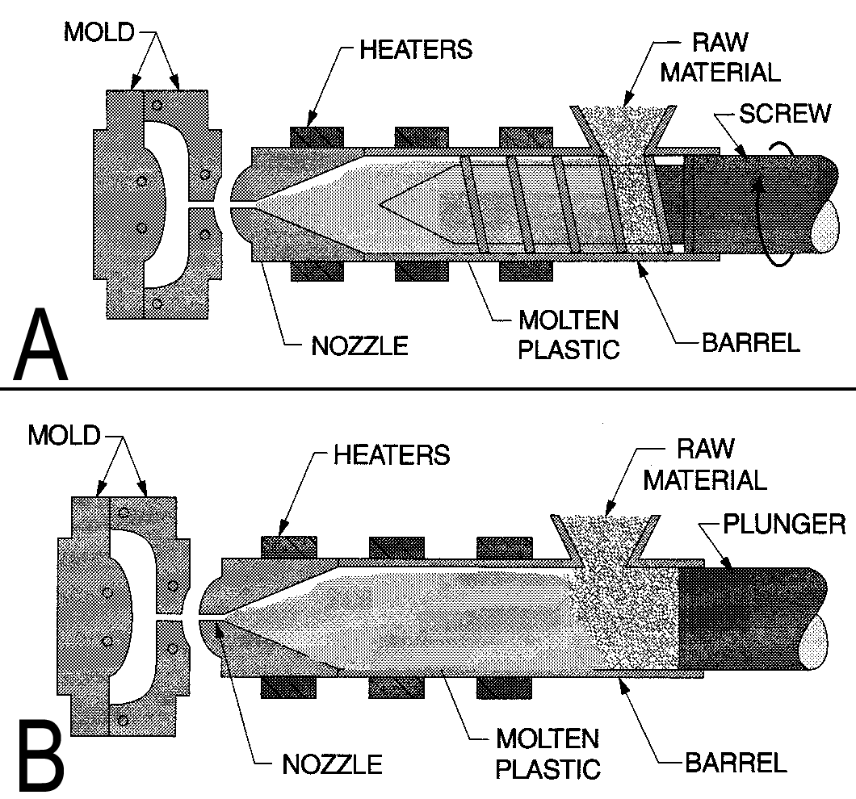***1.2 Injection Molding***Injection molding is the conventional and more common manufacturing process to produce parts. It has been the industry's standard for decades. Injection molding can either be "screw-plunger" or just "plunger" (*Figure 1).* [1]

Figure 1. Schematic for a screw plunger (A) and plunger (B).

In both injection molding methods, the raw material, which is in form of pellets, is thrown into a hopper that is connected to a barrel. The barrel heats the pellets and eventually turns them into melt. If screw-plunger injection molding is used, a faster process is obtained. The screw works to distribute the heat evenly and more uniformly to the pellets when they enter the hopper. Therefore, the pellets melt rapidly. Another function of the screw is that it can mix the pellets with additives that change the original color of the raw material. [1]

At the end of both processes, the molten material is transferred into a mold through a nozzle. Plunger injection molding, however, is also equipped with a ram that forces the melt into the nozzle before it is transferred to the mold. The mold has a sprue in which the molten plastic first enters the mold. Runners in the mold distribute the melt to all cavities evenly. A gate connects the runners to the mold cavity that gives the polymer its final shape. Thus, the mold is also useful in that it can give the part its final shape, geometry, and dimensions. Molds are usually machined from stainless steel for its inertness. They can have more than one piece. At the end of this process, extra filings that result from injection molding can be removed from the channels. These can be reground by chopping and recycling. [1]

1.3 Three Dimensional (3-D) Printing

3-D printing is a newer and non-conventional way of producing parts. With more advancement, 3-D printing is quickly becoming a norm in the industry over the past two decades. This additive manufacturing method is unique in that it can rapidly prototype complex and customized parts. [1]

Many of the "design-for-manufacturing" limitations that arise from using traditional methods are eliminated in 3-D printing. However, there is still the drawback of size limit of the part that the 3-D printer can produce. This problem is solved by producing parts in more than one stage and then combining them by hot air welding or bonding. [1]

In 3-D printing, the part is built "from the bottom up, layer by layer." The 3-D printer has the ability to produce complex parts containing undercuts and internal channels. However, these may require more processing by traditional means. The manufacturing cost is still reduced since a single part that contains many components is produced in only one step. The part produced by the 3-D printer is usually very close to the final shape. If this part needs adjustments, the electronic design file (STL format, from **ST**ereo **L**ithography) can easily be modified to quickly re-produce the part. [1]  
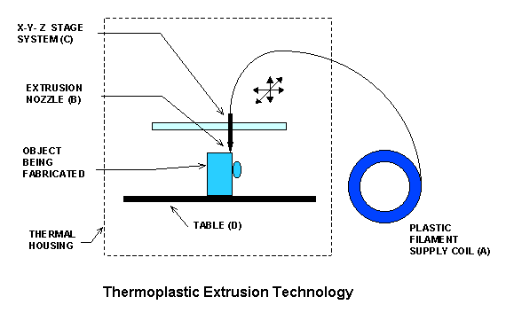

Printers that use Fused Deposition Modeling (FDM) draw the polymeric material, which is in filament form, from a supply spool through a nozzle (*Figure 2)*. The nozzle heats up the filament and subjects it to shear forces that decrease its viscosity. With the help of resistive heaters (known as liquefiers), the nozzle also maintains the material at a temperature above its melting so that it can flow easily. The layers of the desired part start to form one by one after being extruded from the nozzle. The polymer layer bonds with the previous layer immediately when deposited. It also hardens instantaneously. When a layer is completely deposited, the platform in the printer lowers so that the nozzle deposits the next layer. [1]

Figure 2. Schematic of a Fused Deposition Modeling instrument [2].

FDM printers have the ability to produce parts that are up to 100 x 100 x 65 cm in dimensions. The extruder die diameter in these printers determines the vertical dimension and the thickness of the layers. [1]

1.4 Polymer-Fluid Mechanics  
The viscosity observed at the limit of low shear rate ($\dot{γ}$) is called zero-shear viscosity ($η_{0}$). In other word, zero-shear viscosity is a polymer’s viscosity whilst at rest. The temperature at which $η_{0}$ is observed is related to $η_{0}$ by an Arrhenius relation, as seen in Equation 1 [3]:

$η\left(T\right)=A{*η}_{0}* e^{E/{RT}}$, (1)

Where

*η(T)*: Temperature dependent viscosity (Pa.s),

$η_{0}$: Zero-shear viscosity (Pa.s),

$A$: Arrenhius constant,

$E$: Activation energy (J/mol),

$R$: Gas constant (J/mol K),

$T$: Zero-shear viscosity temperature (K).

When above some critical molecular weight, zero-shear viscosity is assumed to be proportional to the weight average molecular weight of the polymer raised to the power of 3.4 as shown in *Equation 2* [3]:

$η_{0}∝{{\overline{M}}_{w}}^{3.4}$, (2)

where

$η_{0}$: Zero-shear viscosity (Pa.s),

${\overline{M}}_{w}$: Weight average molecular weight (g/mol).

The flow rate of a fluid through a cylindrical nozzle is governed by Poiseuille’s equation

$Q= \frac{π\left(P_{app}-P_{atm}\right)R^{4}}{8ηL}$ (3)

where

Q: Flow rate through the nozzle,

Papp: Pressure applied to the fluid,

Patm: Atmospheric pressure,

R: Radius of the cylindrical aperture,

η: Viscosity of the fluid,

L: Length of the aperature,

2. EXPERIMENTAL PROCEDURES

2.1 Material

The feedstock polymer used was a gray polylactic acid with a wire diameter of 1.75 mm.

2.2 Testing Procedures

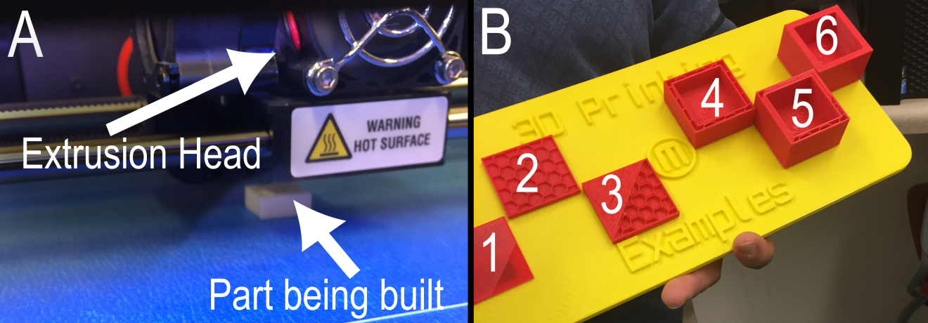

Figure 3. (A) Extruder Head in action (B) Stage wise construction of cube

The file for printing a hollow cube was loaded from a pre-programmed selection. On the virtual software, the cube was set to print on top center of the stage (*Figure 3)* with the following specifications:

* Cube side of 1.5 cm
* An interior fill of 10%
* An outer layer shell thickness of 0.30 mm
* Two outer shells
* Low resolution (meaning no supports will be needed to added)
* Extruder speed while printing 90 mm/s
* Extruder speed while traveling 150 mm/s
* Extruder temperature of 190 °C

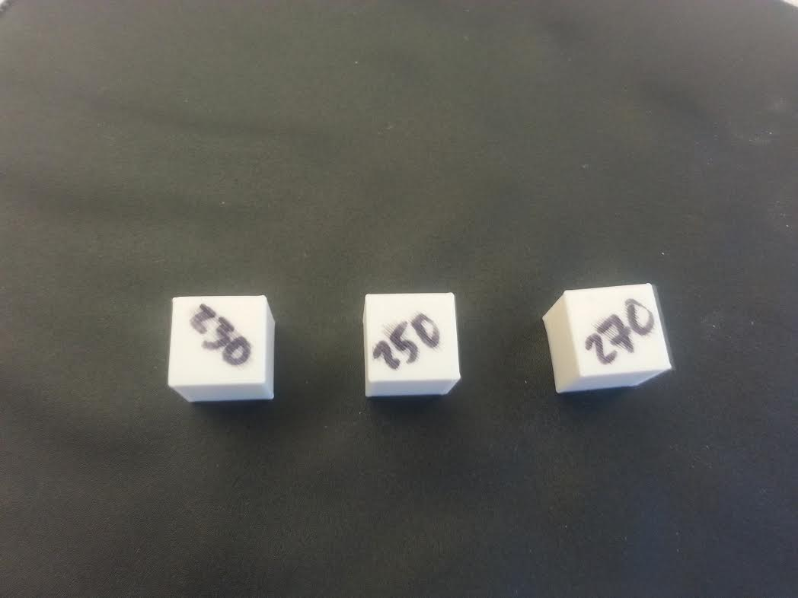After printing the first cube, the program was executed again with the extruder temperature set to 210, 230, 250, and 270 °C. Once all five cubes had been printed, the top surface of each cube was viewed under stereomicroscope and an image was captured.  
  
**3. RESULTS**Three of the printed cubes can be seen in *Figure 4.* To the bare eye, the cubes all look identical. Under stereomicroscope, differences in the bead line size can be seen (*Figure 5).*

Figure 4. Final product of the 3-D printing.

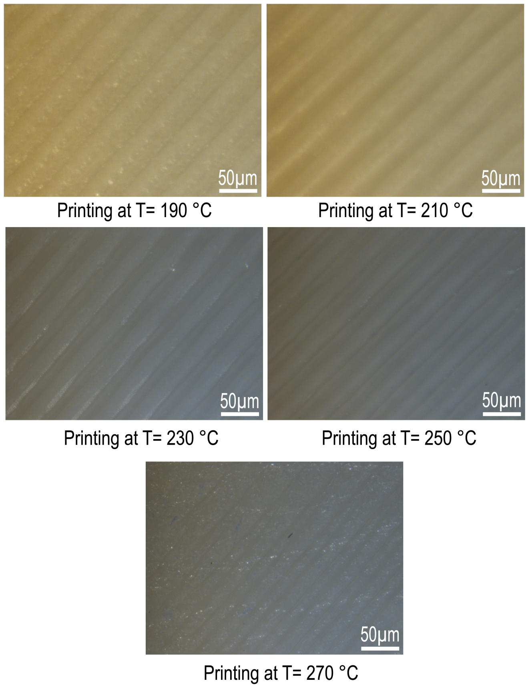

Figure 5 Stereomicroscopic photographs of the five printed cubes at different temperatures.

4. DISCUSSION

4.1 Effect of Temperature

Qualitatively, the temperature of the extruder head had a visible effect on the viscosity of the polymer being extruded. This resulted in the polymer spreading out more at higher temperatures. Thus, the polymer bead lines are most distinct at lower temperatures. For this reason, it is generally desirable to set the extruder head to a temperature that is just above the melting temperature of the polymer so that the polymer will have a small enough viscosity to flow through the extruder, but not so small that it flows too easily after the polymer has left the head. For practical reasons, this often results in a trial and error method to find the optimal extruder temperature.

It is important to remember that the temperature dependent viscosity is not linear but follows an Arrhenius relation (*Equation 1)*. For example, if a polymer has a viscosity of 50% of its zero-shear viscosity at 270 ° C and a viscosity activation energy of 75.80 kJ/mol, then its zero-shear viscosity temperature is calculated by

$0.5=A*exp⁡\left(\frac{75800 J/mol}{8.314\frac{J}{mol K})*(270+273)K}\right)$

$A=2.6*10^{-8}$

$1=2.6*10^{-8}*exp⁡\left(\frac{75800 J/mol}{8.314\frac{J}{mol K})*T}\right)$

$T=521.5 K=248.5 ° C$

4.2 Effect of Molecular Weight

The molecular weight of the polymer being extruded also plays a strong role in its viscosity. Qualitatively, polymers with lower molecular weight will be less viscous than polymers with higher molecular weight due to stronger intermolecular interactions. For molecular weights higher than the critical molecular weight, the viscosity dependence upon molecular weight is known to follow Equation 2. For example, a polymer with M.W. of 192,000 g/mol will have 41% of the viscosity of the same polymer with M.W. of 250,000 g/mol.

4.3 Effect of Extruder Nozzle Geometry

As extruder nozzles are almost always cylindrical, the flow rate of polymer fluid through the nozzle can be modeled by Equation 3. From that equation, the flow is dependent upon the radius of the nozzle to the fourth power and inversely depending upon the nozzle length. For example, if the pressure, viscosity of the polymer, and nozzle length are held constant, a nozzle with a radius of 0.75 mm will have 81 times the flow rate of the nozzle with radius 0.25 mm. In order to adjust the flow rates to be equal, the nozzle length of radius 0.75 mm would have to be 81 times longer than the nozzle of radius 0.25 mm.

In practicality, cutting a nozzle down to 81 times its original length would not be the best option, and more likely the pressure and/or temperature would be increased to compensate for the smaller radius.

5. CONCLUSIONS

Five high quality hollow cubes made of polylactic acid were successfully printed by the Makerbot 3D-printer. Varying the temperature of the extruder made little difference that the human eye could detect. However, upon closer examination with a stereomicroscope, it was found that the cubes printed at higher temperatures had closer bead lines due to the decreased viscosity of the extruded polymer. While it was not directly studied in this lab, the molecular weight of the polymer used and nozzle geometry have a strong effect upon the extrusion process and must be optimized to obtain a high quality product.

6. ACKNOWLEDGMENTS

The group would like to acknowledge the Department of Agriculture and Biosystems Engineering for allowing us to use the 3-D printer and providing a file template for the hollow cubes.

7. REFERENCES

1. Mendoza, J. D., *Additive manufacturing and rapid prototyping of parts using polymeric materials*, Iowa State University. Web.

2. Castle Island Co. *Thermoplastic Extrusion*. Web.

3. Mendoza, J. D., *Mat E 453 Lecture*, Iowa State University.